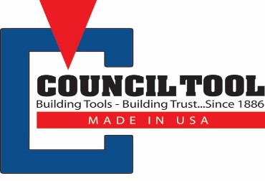
Council Tool’s warranty policy flows through our dealers and distributors. We will assist and provide any support we can offer to assist in any warranty claims. Our warranty policy is listed below:
- Council Tool warranties each Council Tool product, which states that it comes with a “limited lifetime warranty” to the original end-user purchaser for as long as the original end-user purchaser owns the product, against deficiencies in material and workmanship.
- This “limited lifetime warranty” does not cover products that are damaged resulting from improper handling or storage, tools that are improperly used, abused, altered, or damaged due to improper or lack of proper maintenance & repair or normal wear and tear of the product. Deficient products will be replaced or repaired.
Council Tool guarantees products will be received free of manufacturing defects. Our “limited lifetime warranty” is good for 45 days from receipt of product with proper usage. Our “limited lifetime warranty” does not cover tools that are abused, are used improperly, or are altered, no matter the length of time from receipt of product.
This “limited lifetime warranty” applies only if the product was purchased from Council Tool or an authorized Council Tool dealer or distributor, unless otherwise prohibited by law. Council Tool reserves the right to reject warranty claims for products purchased from unauthorized sellers, including unauthorized internet sites.
When replacing a tool for a customer, please provide us with pertinent details so we may issue credit. As always, feel free to reach out to us with any questions or if you need assistance in dealing with a warranty claim.
Thank you for supporting Made in the USA tools.

